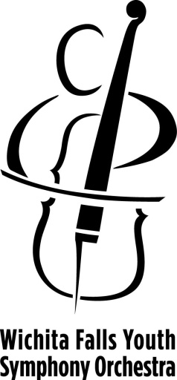
Performance Request

Wichita Falls Youth Symphony Orchestra

String Ensemble
Event date __________________ Start and end time for performance _________________
Name of Event/Function _____________________________________________________________________
Name of Organization ________________________________________________________________________
Performance location (please provide address) ___________________________________________________
Contact person _____________________________________________________________________________
Phone number __________________________ Email address _______________________________________
Donation offered ___________________________________________________________________________
Additional notes about performance desired (for example, if the music will be background while other activities are happening, if musicians will be fed, if space is limited, if performance is outdoors, or anything else you’d like us to know!) __________________________________________________________________________________________________________________________________________________________________________________________________________________________________________________________________________________________________________________________________________________________________________________________________________________________________________________________________
Student musicians in the String Ensemble are the YSO’s musical ambassadors. They are all volunteers sharing their gift of music with the community. The Ensemble is available for private & public functions hosted by businesses, nonprofits, civic clubs, individuals or other organizations.
Students are typically accompanied by Ensemble conductor Ms. Gina Menden or by another supervising adult. Unless otherwise requested, they will arrive 15 minutes prior to performance and will wear concert black, and bring their own music stands. Chairs will need to be provided for all performers.
All performance requests may be submitted to the YSO offices, care of Jean Hall, executive director, by email jhall@wfyouthsymphony.org or mail 1300 Lamar, Wichita Falls, TX 76301
Performance requests received less than 3 weeks prior to the date of the event may be difficult to fulfill. The shorter the lead time of the request, the less likelihood of the Ensemble being able to accept the request. The YSO is a 501(c)3 nonprofit organization and operates on a donation basis. All donations are tax deductible and will be acknowledged in writing. A $100 minimum donation is recommended for Ensemble performances.

